

**Department of Software Engineering**

**Faculty of Computer Science & Information Technology**

**The Superior University, Lahore**

**Name:** MUHAMMAD HAMZA ALI

**Roll No:** SU92-BSAIM-S24-032

**Section:** 3A

**Subject:** ARTIFICIAL INTELLIGENCE(LAB)

**Task No:** Lab-Task 3

**Task-3**

**Model Based Reflex Agent**

**1. Introduction:**

The Model-Based Reflex Agent is a Python implementation designed to simulate an intelligent system that reacts to temperature variations. The agent makes decisions based on its past actions and a predefined threshold, showcasing a fundamental concept of artificial intelligence in decision-making systems.

**2. Features:**

The application provides the following features:

* **Threshold -Based Decision Making:** The agent turns a heater ON if the temperature is below a certain threshold and OFF otherwise.
* **State Memory:** The agent remembers its last action to avoid redundant commands.
* **Dynamic Perception:** It continuously evaluates the environment (temperature readings) and responds accordingly.

**3. Implementation Details:**

The application is implemented in Python using a class-based structure.

* **Class ModelBasedreflexAgent:**
* **__init__(self, threshold):** Initializes the agent with a temperature threshold and a memory of previous actions.
* **perceive_temperature(self, temperature):** Evaluates the current temperature, compares it with the threshold, and decides whether to turn the heater ON or OFF.

**4. User Interaction:**

* The agent is initialized with a threshold value (default 22C).
* A list of temperature values is simulated.
* The agent checks each temperature reading and determines the appropriate action.
* The system ensures the heater does not switch states unnecessarily.
* The output displays temperature readings along with the agent’s response.

**5. Example Usage:**

* Temperature: 20 C Turning Heater ON
* Temperature: 21 C Heater remains ON
* Temperature: 11 C Heater remains ON
* Temperature: 18 C Heater remains ON
* Temperature: 19 C Heater remains ON
* Temperature: 23 C Turning Heater OFF

**6. Output:**

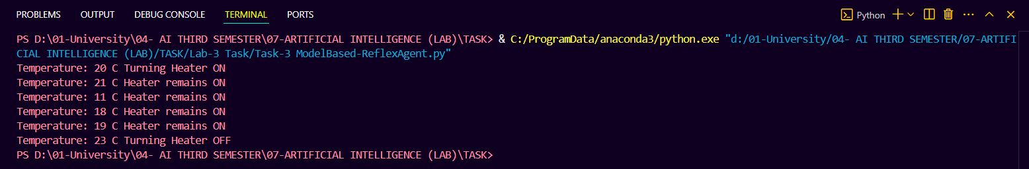

**7. Conclusion:**

The Model-Based Reflex Agent effectively demonstrates AI-driven decision-making based on past actions and environmental perceptions. Future improvements may include adding more sensors, adaptive threshold settings, or integrating with a real-world IOT heating system.